# Topic of the project

“Blog using Flask python”

# Why is the particular topic chosen?

Blogging is a way of sharing your thoughts, ideas, and experiences with the world. It can be a great way to connect with people who share your interests and to build up a following of loyal readers. Blogging is a great way to connect with people who share your interests. By reading and commenting on other blogs, you can make new friends and build up a network of like-minded people.

# Introduction

A **blog** is a type of **website** that is updated regularly with new content. Most blogs contain short, informal articles called **blog posts**. These posts usually contain some combination of **text**, **photos**, **videos**, and other media. At its core, a blog is just a space on the Web that you can create to record and express your **opinions**, **experiences**, and **interests**.

If you spend much time browsing the Web, you've probably read a blog post before, even if you didn't realize it at the time. Some of the most-read blogs are a bit like online magazines because they're written by a team of people who are paid to update the blog with new posts several times a day.

However, a **majority** of blogs are written by one person. As a result, the average blog is fairly **personal**, reflecting the**interests** and **personality**of the person who writes it. This is the type of blog we'll focus on in this tutorial.

# Objective and Scope

As you saw in the infographic on the last page, most bloggers consider blogging a **hobby**. It can be a fairly time-consuming hobby, as many bloggers spend several hours each week writing blog posts, replying to comments, and more. So why do they do it?

There are many reasons why people blog, but here are some of the most common reasons:

* To share your experiences and expertise
* To speak up about an issue you care about
* To become more involved with hobbies and passions
* To be part of a community
* To advance your career or start a career in writing
* To keep family and friends updated about your life

A blog can be about literally **anything**. There are people blogging about every topic imaginable, from their political views to their pets. Think of **any interest or hobby**, no matter how unusual or specialized—there's bound to be an entire community of blogs devoted to discussing it. Although it's impossible to list all of the subjects people blog about, there are certain topics that are commonly covered.

* Methodology

**Project flow Diagram**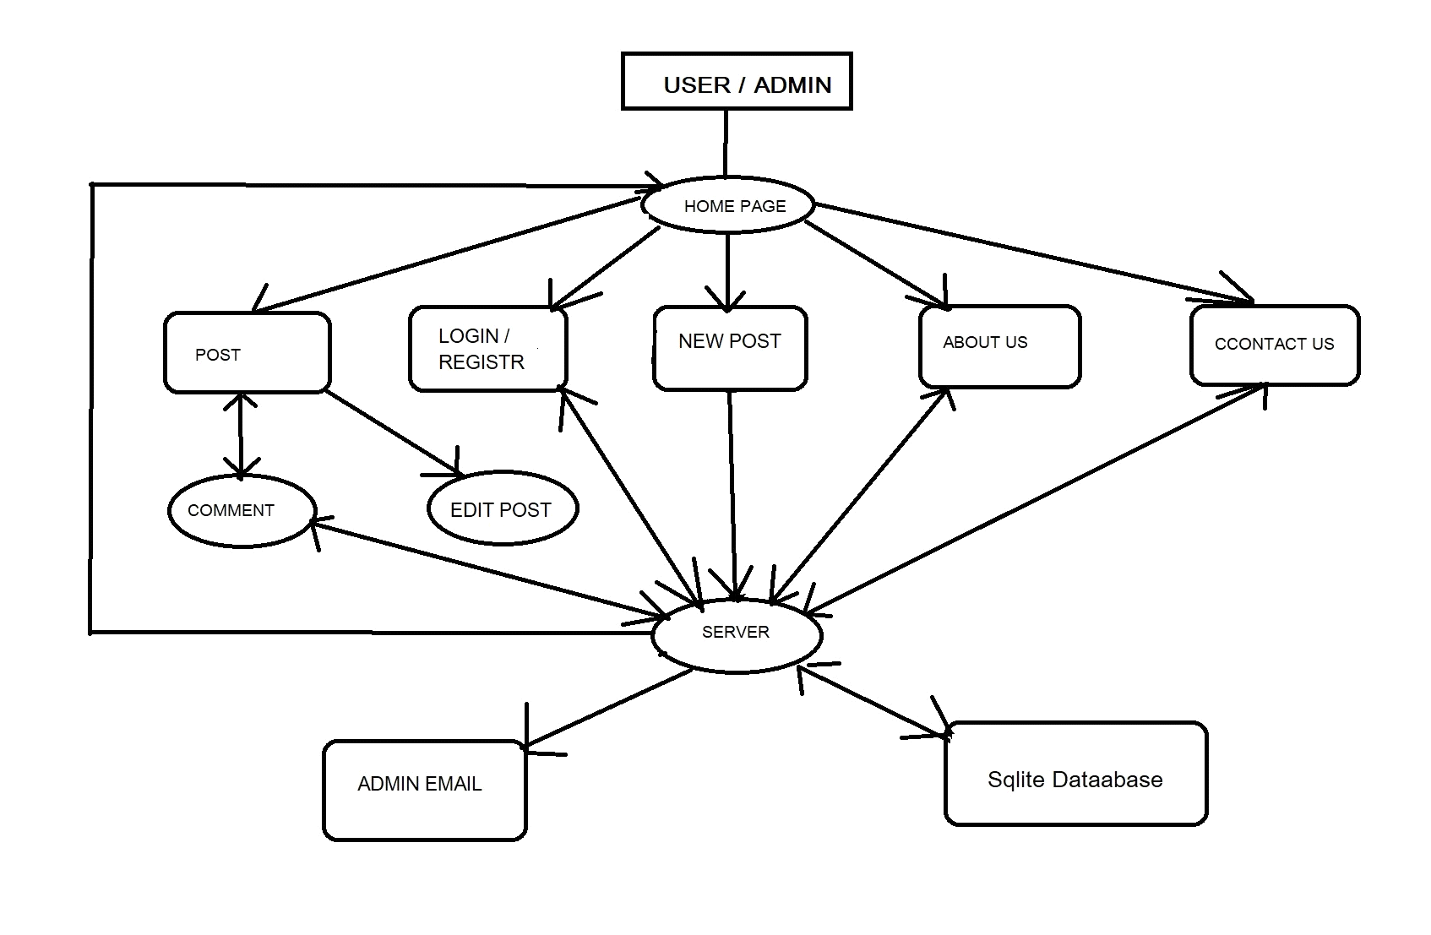

**Fig :** Project flow Diagram

* Requirements

Operating System : Windows 10 or later version

IDE : Pycharm , vscode

Interpreter : Python

Modules/Tools : flask , jinja , html-css

# Conclusion

We created blog project using flask in python , when we start to create this project we learned about frontend technology like HTML-CSS, jinja, bootstrap. and For backend technology like flask, flask_wtf, functools, werkzeug,flask_sqlalchemy, wtforms, flask_ckeditor, flash_login, flask_gravatar & smtplib . for database we used SQLite-database.

Although blogging might seem like the work of an author or writer, you could actually explore it as long as you know where you are good at and what you want to talk about. If you’re a professional programmer and want to explore blogging this time, get that opportunity and start your blog. A few more tools, time, and commitment to help you with the writing process is all you need to establish a blog that will rock the programming world.